BIOMETRIC DEVICE

INSTALLATION

Prepared by CHI, MoHFW
DATE - 12-01-2022

TABLE OF CONTENTS
- Download link for Mantra RD Service Setup 3
- Mantra MFS100 Driver Setup Installation 4
- Mantra RD Service Installation 6
- Public to L0 Conversion (MFS100 Registered Device) 8
- RD Service Test Application 9
- Proxy Setting 11
- Browser Configuration for Web RD Test 13
- Device Registration on Management Server 16
- Technical Support 16

This user manual has been prepared for the use of UIDAI certified Mantra MFS100 Biometric device only. The instructions mentioned in this user manual may vary with other brands of UIDAI certified biometric devices.

List of UIDAI Certified Biometric Authentication Devices.
Please click here on this link to see the list of Aadhar approved biometric devices, your device should be one of this list.

https://uidai.gov.in/images/resource/list_of_UIDAI_certified_device_vendors_06_05_2021.pdf

This documentations is prepared for Mantra RD Service & MFS100 Driver Setup.
Installations process will be different for different manufacture devices accordingly you should follow your device manufacturer guidelines for installations.

Download link for Mantra RD Service Setup.
Registered device service of MFS100 is fully compatible with latest Aadhar Authentication API
2.0 (rev 1).
Registered device service Setup for MFS100 is available on our download portal http://download.mantratecapp.com/Forms/DownLoadFiles

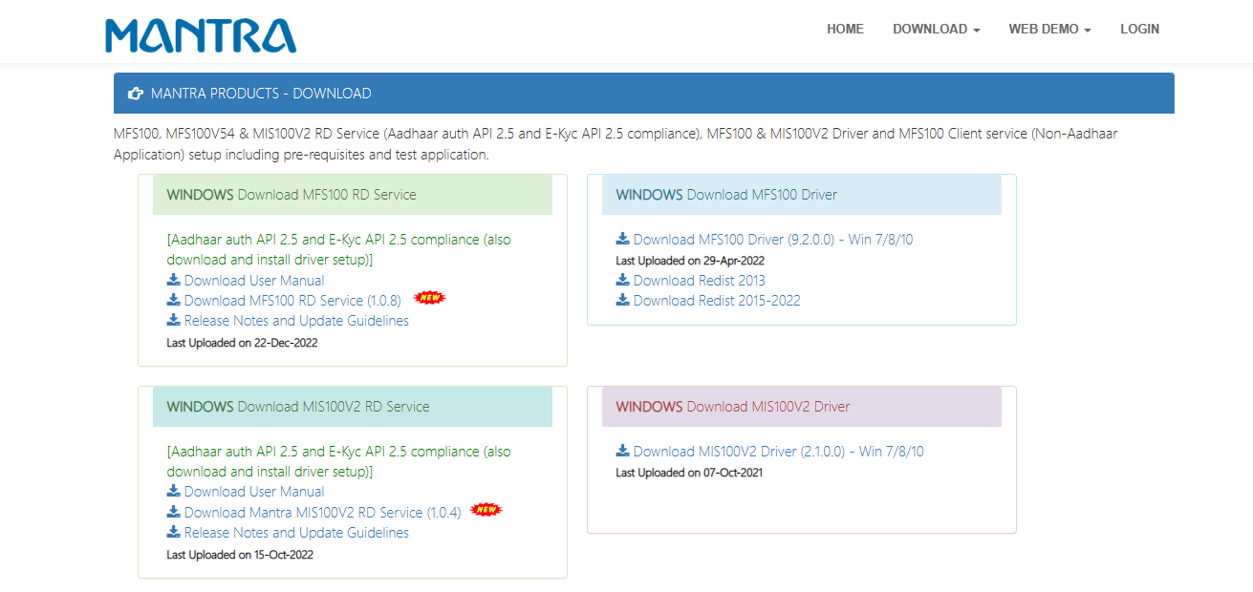

Click on both link and download.
Download MFS100 RD Services
Download MFS100 Drivers
Install Mantra RD Service & MFS100 Driver Setup.

Mantra MFS100 Driver Setup Installation.
    - Start installation:
Right click on setup file and select “Run as administrator”.

Note: To install MFS100 scanner drivers and necessary service, setup need to access system32 folder. In this case setup need administrator privileges.
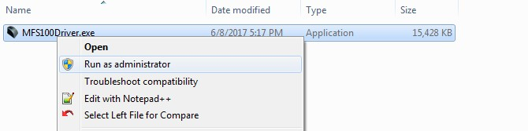

    - Welcome Wizard:
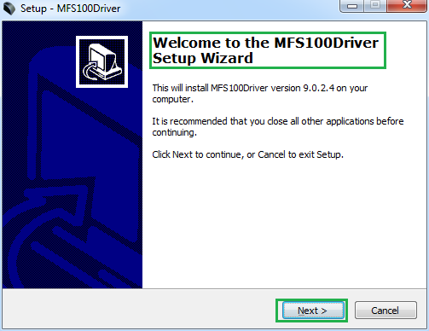

    - Destination Location
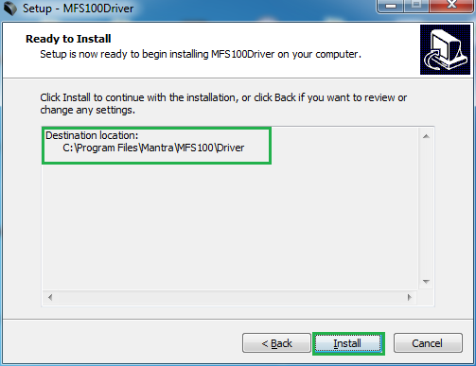

    - Finish Driver Installation
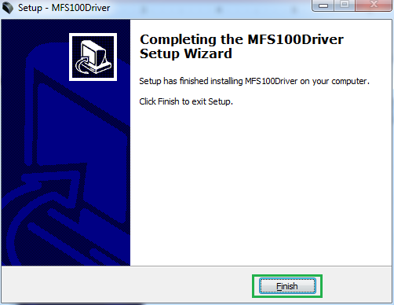

Mantra RD Service Installation.
    - Start installation:
- Right click on setup file and select “Run as administrator”.
- Note: To install Mantra RD Service, setup need administrator privileges.
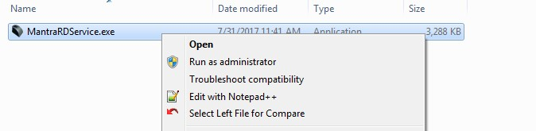

    - Welcome Wizard:
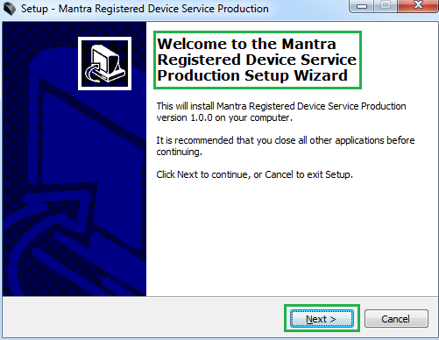
    - Destination Location:
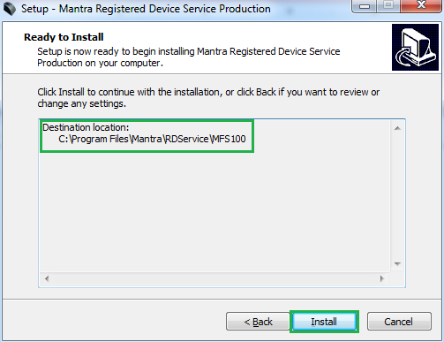

    - Finish RD Service Installation:
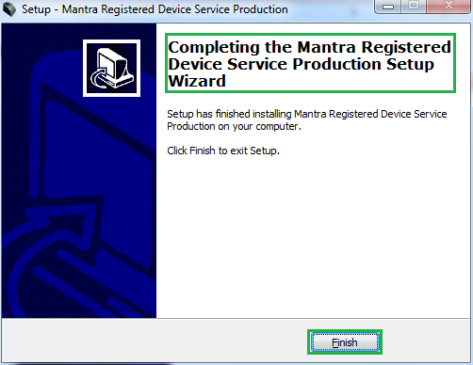

- After installation of RD Service, it can be found under Services form “Control Panel\All Control Panel Items\Administrative Tools”.
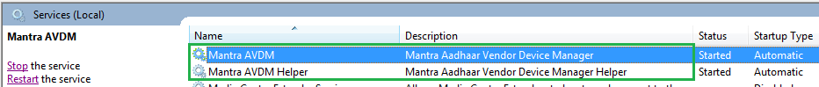

Public to L0 Conversion (MFS100 Registered Device)
- When RD Service will detect public device then it will convert it into registered device and user will be notified again with success response by RD Service.
- After that you need to unplug and plug your device.
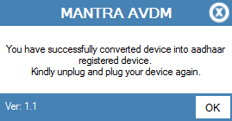
- If your device is not listed at Mantra Management Server than user will be notified with below message so in this case you need to contact with our Servico Team at http://servico.mantratecapp.com Or

+91-79-49068000.
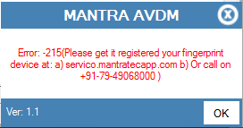
- Once registered MFS100 device will be plugged to the system, RD service will detect it automatically and validate it on Mantra’s Management Server.
- Once validation competed then it will generate below popup for user information.
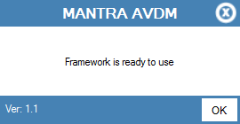

RD Service Test Application

- HTTP : http://rdtest.aadhaardevice.com/
- HTTPS : https://rdtest.aadhaardevice.com/ (Test https URL if your website is in https)

- By running RD Service Test application, user can detect all RD Services installed in their system.
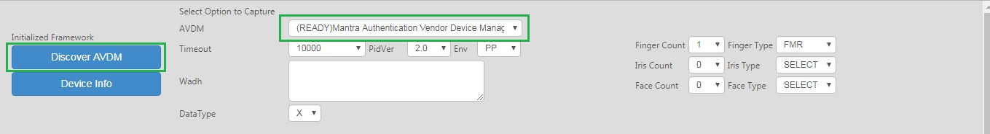
- User can get Device Information which is connected to its system.
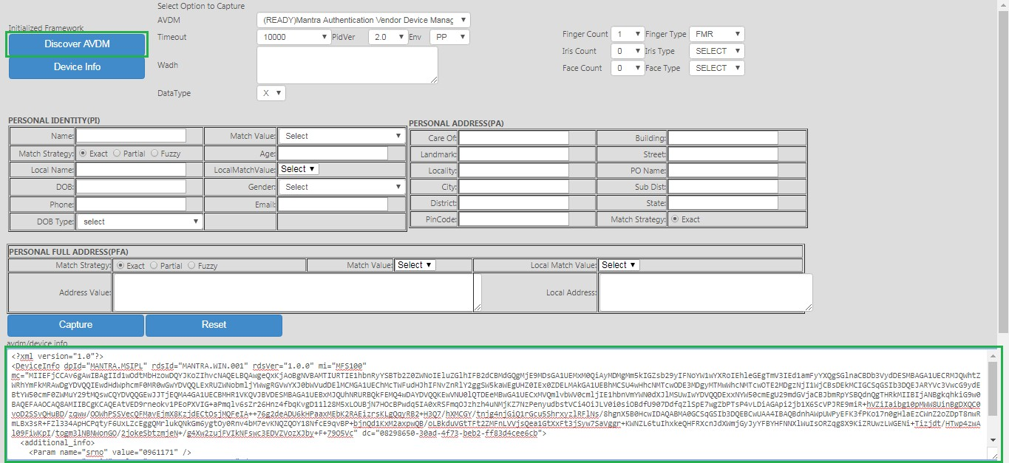

- By calling capture function of RD service, user can capture biometric data.
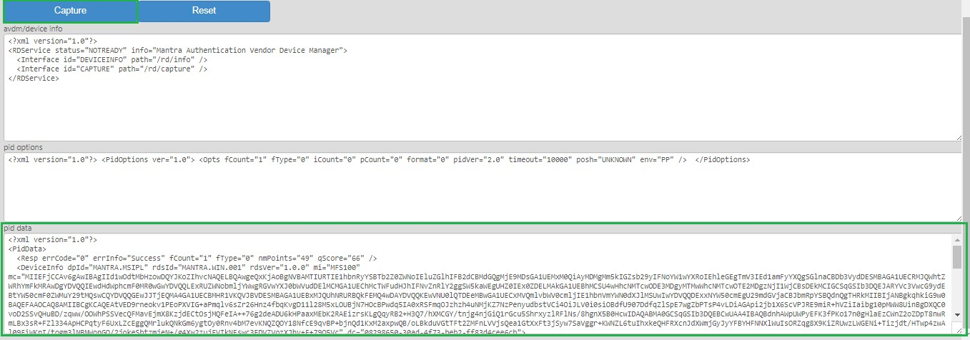

Mantra Management Server
- It is necessary that RD service installed in client machine must interact with Mantra’s Management Server.
- For that, client machine must access the domain https://aadhaardevice.com and it’s all sub- domains.

Proxy Setting

Proxy in Network (if proxy is required to connect internet)

      - After installation of RD Service (updated on 04-Dec-2017) below Application – Config Mantra RDService shortcut will be available on ‘desktop’ as well as in ‘All Programs’.
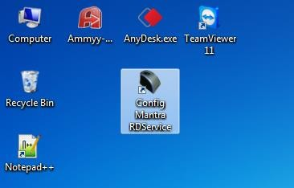
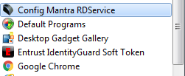

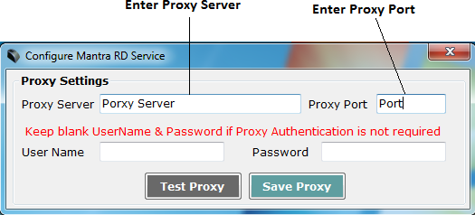

      - Enter Username and Password if Proxy Authentication is required otherwise keep as Blank.
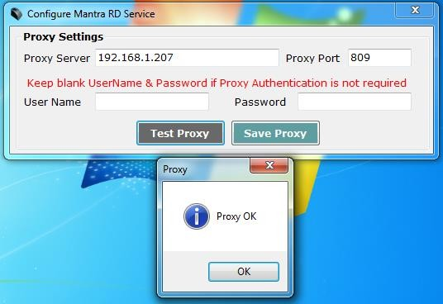
      - On “OK” Message of Test Proxy, click on Save Proxy.
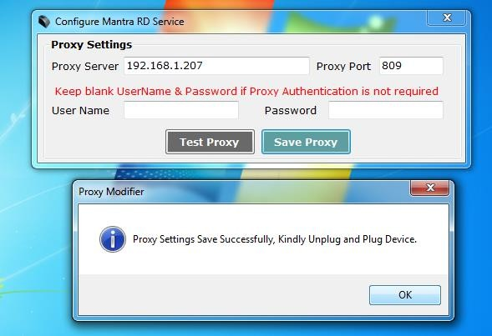
      - You need to “Unplug and Plug” device so RD Service will take that proxy setting to communicate “Mantra Management Server”.

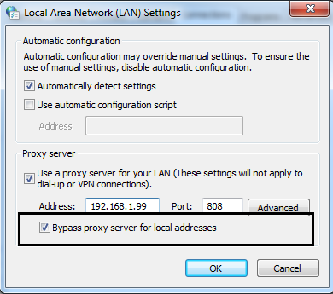

Browser Configuration for Web RD Test

Chrome
Open chrome browser and write below in url and click on Enable “Allow invalie certificates for resources loaded from localhost” and then click “RELAUNCH NOW”

chrome://flags/#allow-insecure-localhost
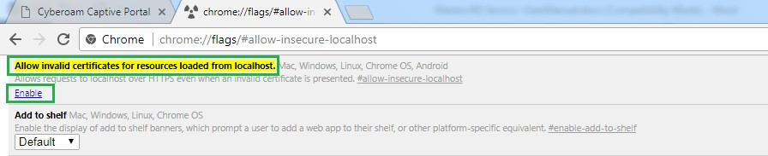

Firefox
Open Firefox browser and write below in url and click on “I Understand the Risks” , click “Add Exception” , it will open Add Security Exception popup and then click “Confirm Security

Exception”. https://127.0.0.1:8005
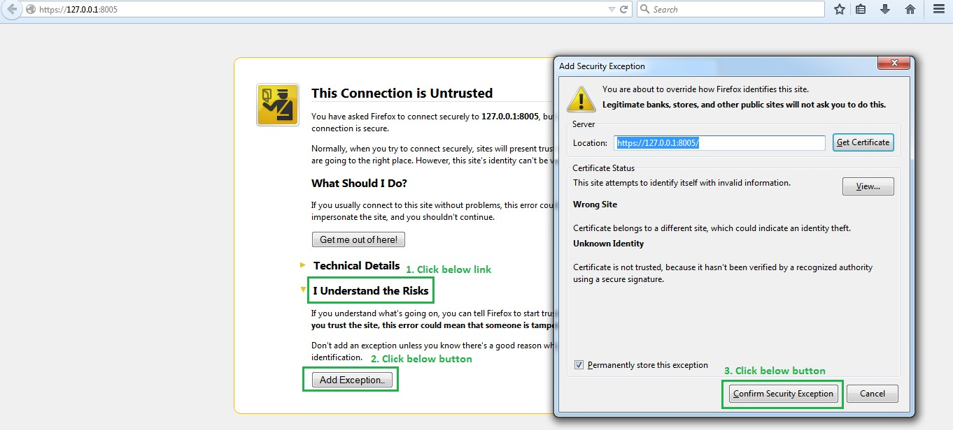

Internet Explorer
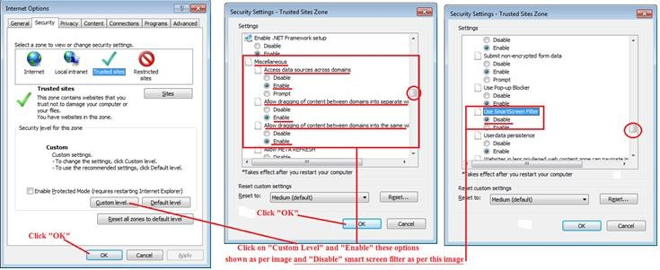

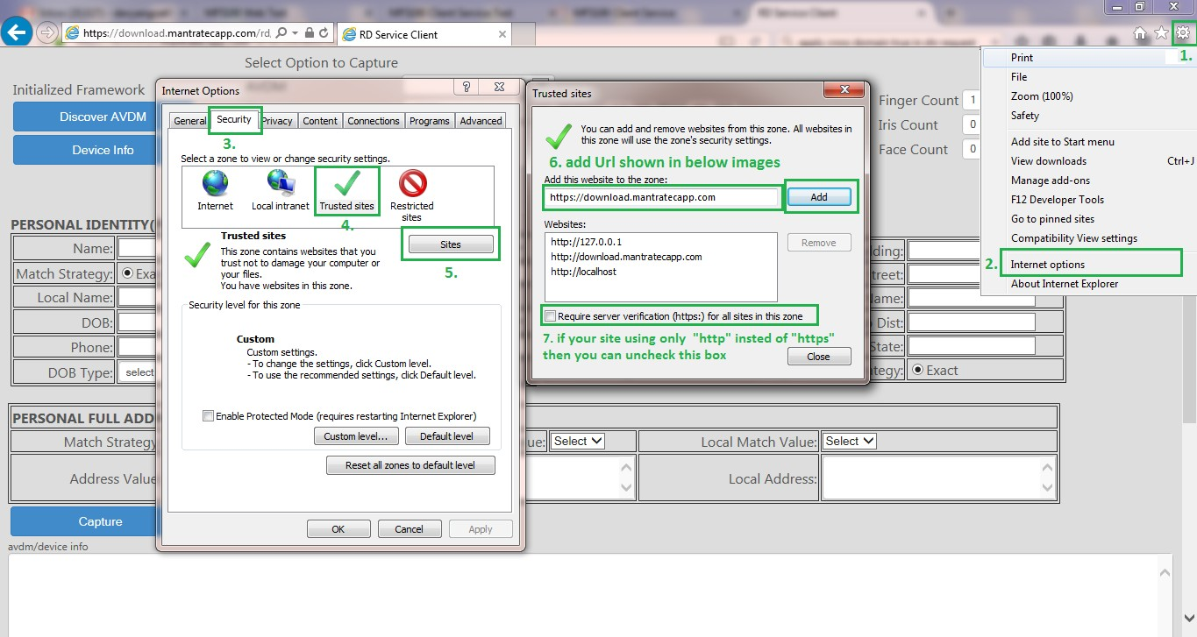

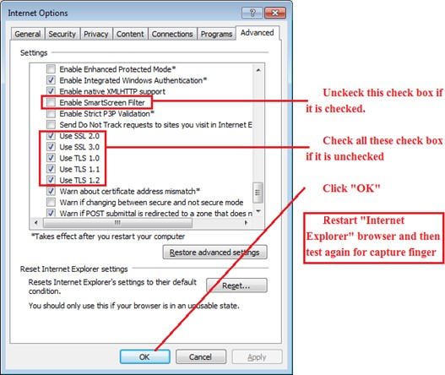

Date Time and Time Zone
