User Manual

Of
Pradhan Mantri National Dialysis Programme Portal
(Facility Module)

Prepared by CHI, MoHFW
DATE - 12-01-2023

Table of Contents
1. Introduction about project 3
2. About User Manual 3
3. User of the applications 3
4. Login Page 4
5. Dashboards 5
6. Edit/View Health Facility Details 6
7. Patient Registration 6
7.1. ABHA Id Available YES 7
7.1.1. Patient Register by OTP 7
7.1.2. Patient Register by Biometric 8
7.2. ABHA Id Available NO 9
7.2.1. Create ABHA ID 9
7.2.1.1. OTP 9
7.2.1.2. Biometric 12
7.2.1.3. Aadhar Demographic 13
7.2.2. Without ABHA ID 14
7.2.2.1. Patient register by DOB and Mobile number 15
7.2.2.2. Link with ABHA ID 15
7.3. Patient List 16
7.4. Download Health Card 16
7.5. Edit Patient Details 17
7.6. View Patient Details 17
7.7. Deactivate/Activate Patient 17
8. Add Machine Master 18
9. Slot Management 19
10. Dialysis Module 20
11. Dialysis History 21
12. Waiting List 21
13. Reports 23
14. Global Search 23
15. Transfer List 24
16. HFR Module 25

Introduction about project
PMNDP portal is a comprehensive web based application which supports system to closely monitor real time data transfer from dialysis facilities to central server of MoHFW. The Pradhan Mantri National Dialysis Program is part of the National Health Mission (NHM) for provision of free dialysis services to the poor. The Guidelines for Pradhan Mantri National Dialysis Program envisages provision of dialysis services under NHM in all the districts of the country.

About User Manual
The User Manual contains all essential information for the user to make full use of the information system. This manual includes a description of the system functions and capabilities, contingencies and alternate modes of operation, and step-by-step procedures for system access and use.

User of the applications
The Application has three User at present:
- Facility Module
- State Module
- National Module
This User manual works for only Facility module.
Click on login icon you will get login page.

Login Page

Enter URL as https://pmndp.mohfw.gov.in/frontend/login
Or click on the login button on the Home Page.

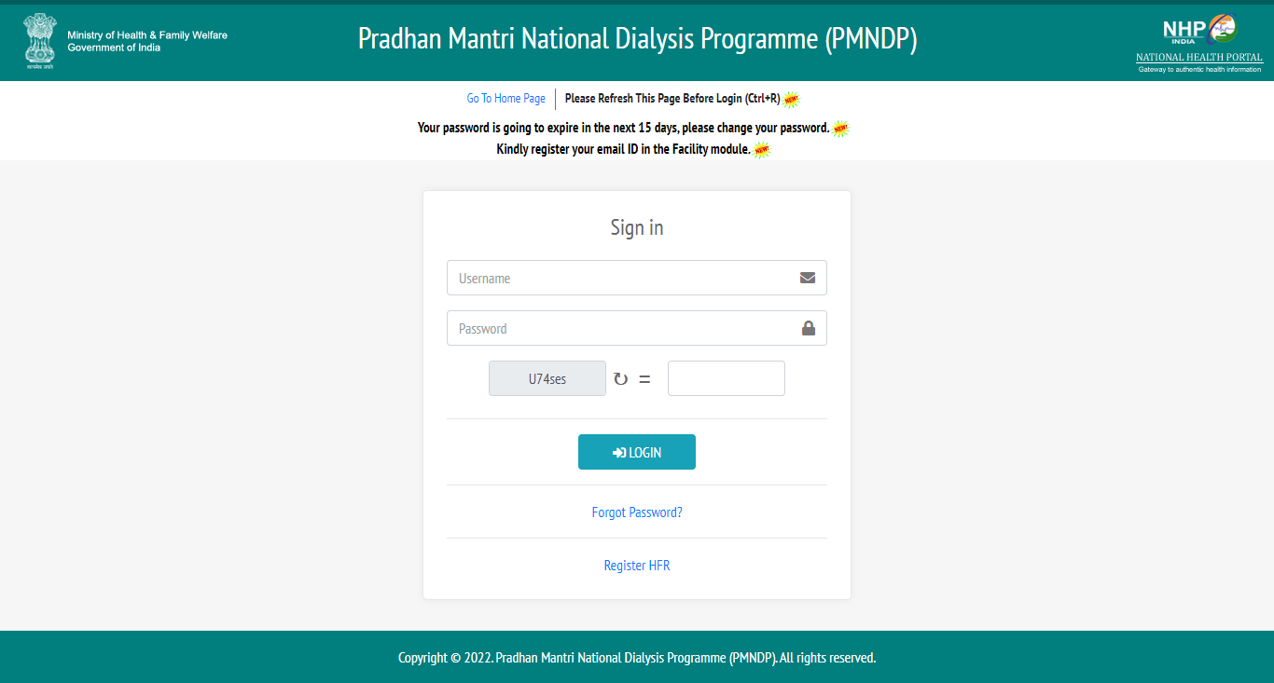

Step1. Enter Valid Username and valid password.
Step2. Enter Valid Captcha.
Step3. Click on login button: If credentials are correct then login is successful and Facility can see the Dashboard.

Forgot Password
Step4. Forgot password: If Facility forgot password then enter the registered email id update new password.

Dashboards
Home screen with menu and dashboard: If login successful then new page will open as below

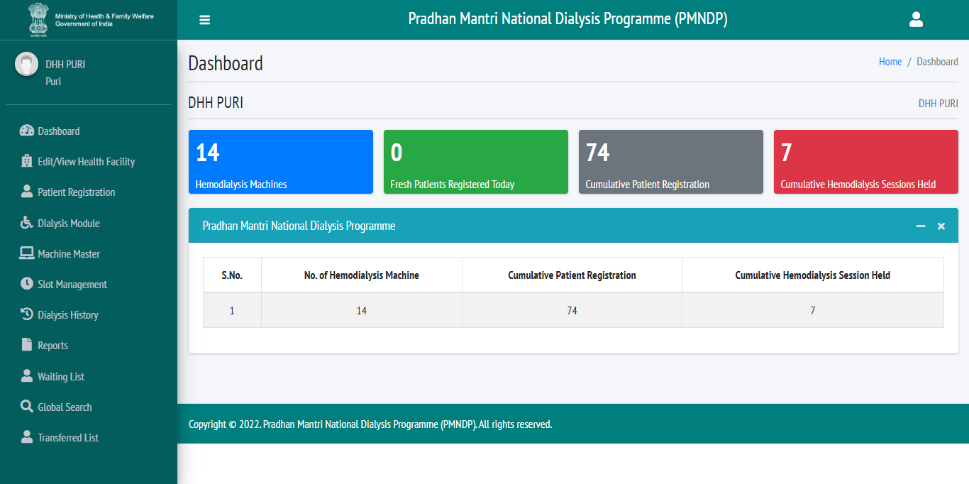

Click on Dashboard link in the menu navigation from the left hand side to view dashboard Dialysis services status under PMNDP.

- Hemodialysis Machine: Displays total hemodialysis machines data in the dashboard.
- Fresh Patient Registration today: Display the total no. of Patient registered today.
- Cumulative Patient Registration: Displays total no. of patient registered in the center.
- Cumulative Hemodialysis Sessions Held: Displays cumulative Hemodialysis Sessions Held in the center.

Edit/View Health Facility Details
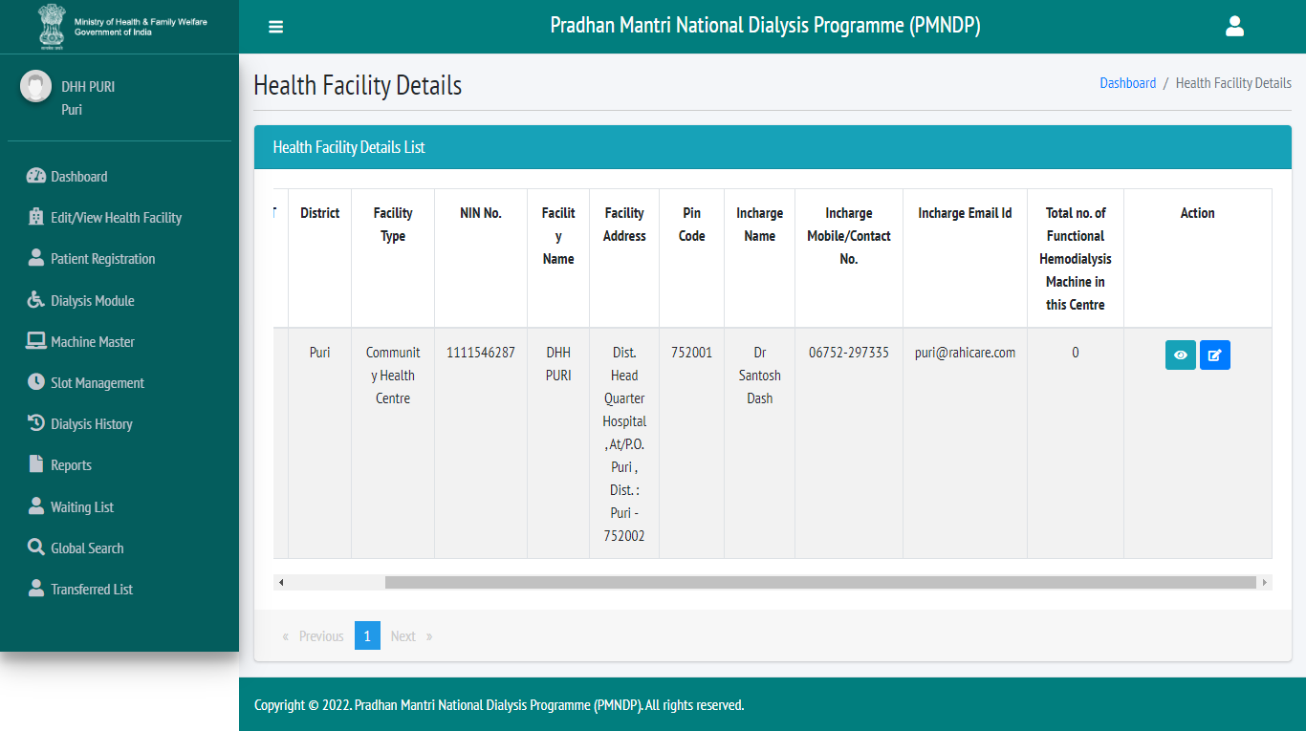

Click on Edit/View Health Facility and Facility can see his profile and facility can view/edit facility details with these fields date, state, district, facility location, facility type, facility name, facility address, pin code, In charge name, In charge mobile, In charge Email Id, NIN Id and Total no. of Functional Hemodialysis Machine in this Centre

Patient Registration
Click on patient registration tab from side menu Facility can see patients list.
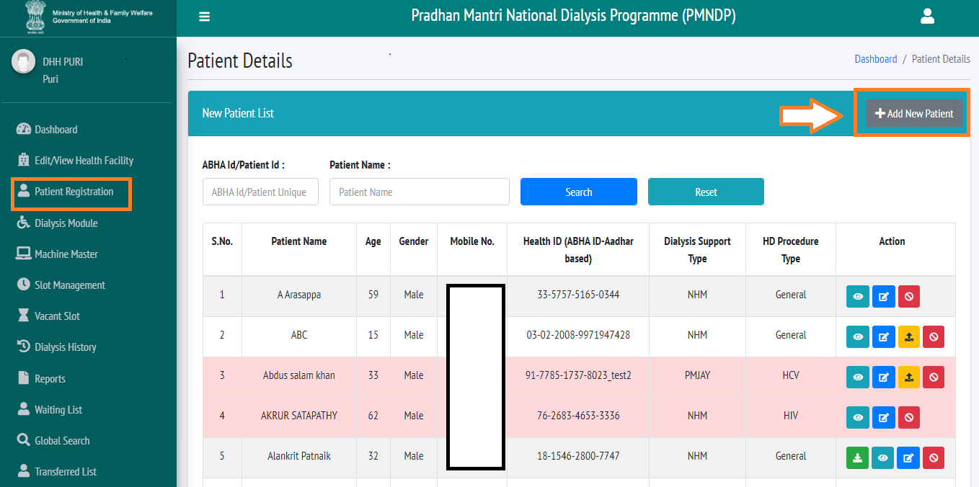
Click on Add new patient icon new popup will open where facility can register the patient.

ABHA Id Available YES

Patient Register by OTP
Patient have available ABHA id so they can add the patient they have to enter ABHA id.
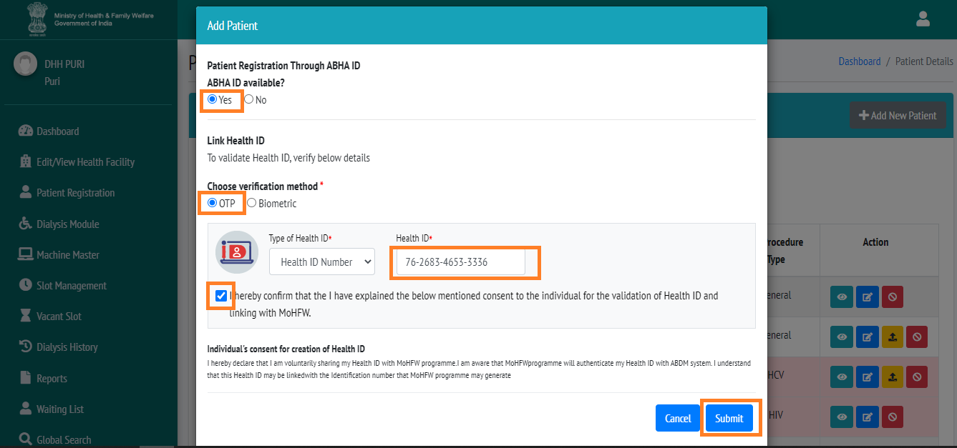

- ABHA ID available select yes.
- Choose verification method select OTP.
- Enter valid Health id.
- Check the confirmation checkbox.
- Click on submit button.
After click on submit you will redirect to OTP page.

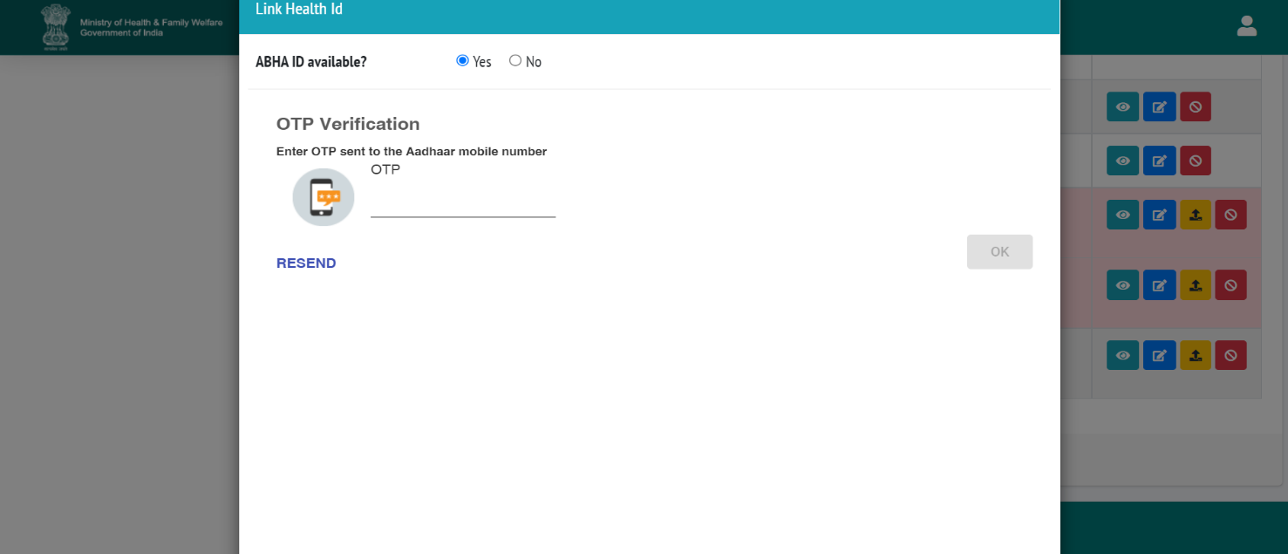
- Enter OTP which will be sent to your registered mobile no.
- Click on OK.

You will be redirect to next page:

- Click on Save.

Patient Register by Biometric

If patient not able to receive the OTP in his mobile number so they can register by Biometric.

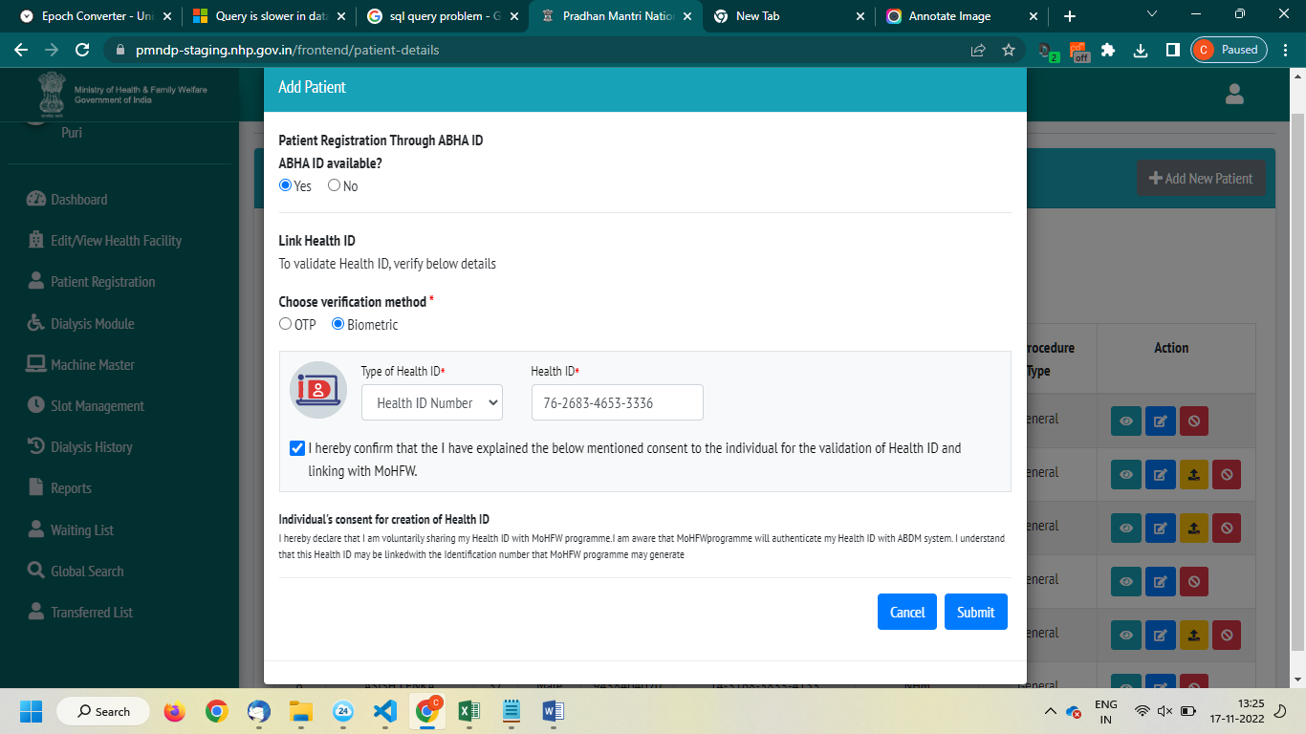
- Click on Yes
- Choose verification method
- Click on Biometric
- Enter Health ID/ABHA ID and submit
- Tick on checkbox and submit

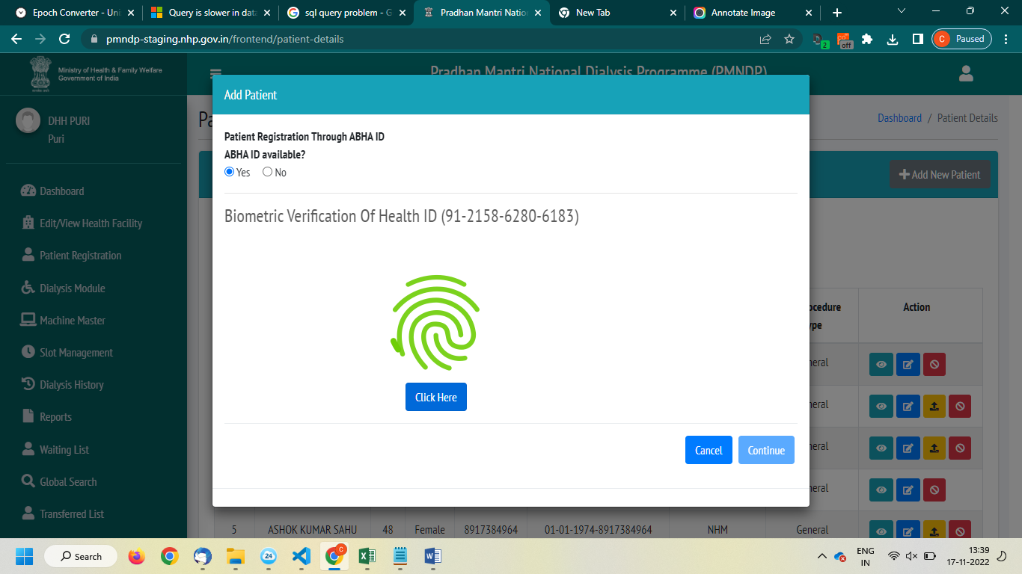
- Click on click here
- Verify your finger and verification successfully then click on continue after verification successful redirect to patient profile page.

ABHA Id Available NO
If the Patient do not have the ABHA ID. Facility can register the Patient in center with two methods.
- Create ABHA id using Aadhar no.
- Create Patient without using Aadhar no with patient date of birth and mobile number.

Create ABHA ID
If the Patient do not have the ABHA ID. Facility can register the Patient in center with three methods.
- OTP
- Biometric
- Aadhar Demographic

OTP
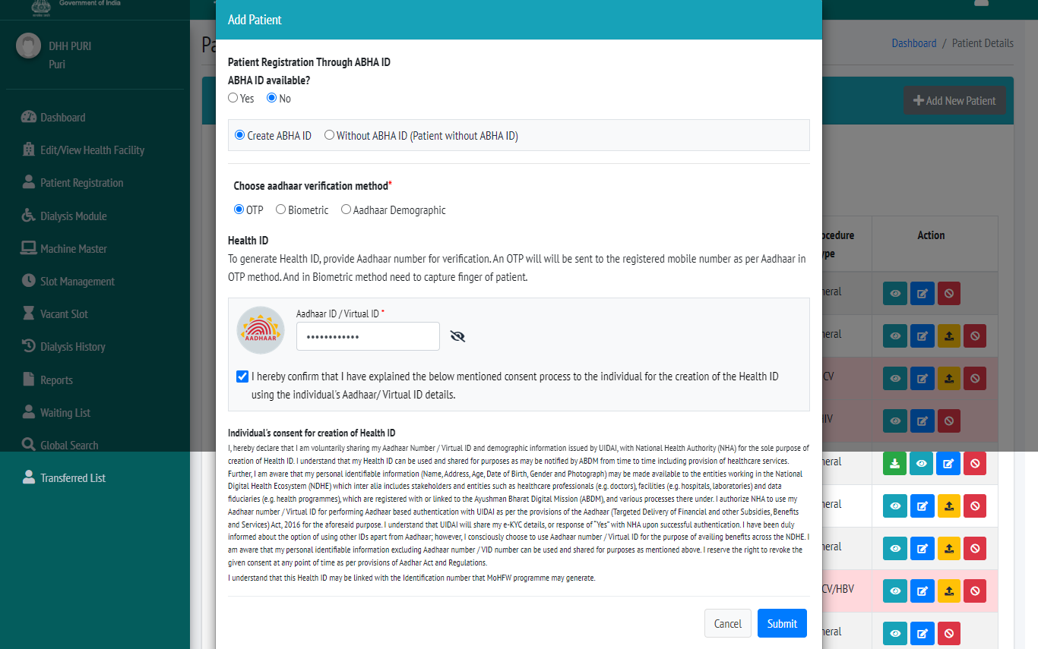
- ABHA ID available select NO.
- Select Create ABHA ID.
- Choose verification method select OTP.
- Enter valid Aadhar number.
- Check the confirmation checkbox.
- Click on submit button.

- Enter OTP which will be sent to your registered mobile no.
- Click on OK.

You will be redirect to next page:
Some records will display auto fill which relate to your Aadhar no.
Enter other details which is mandatory.
Click on Save.

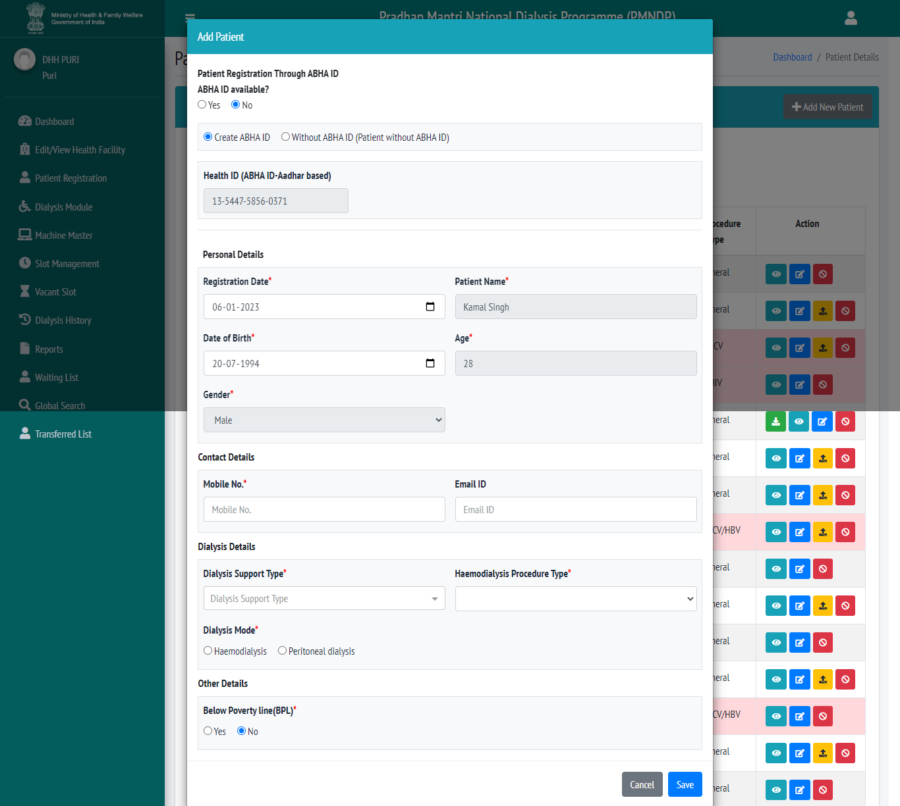

Biometric
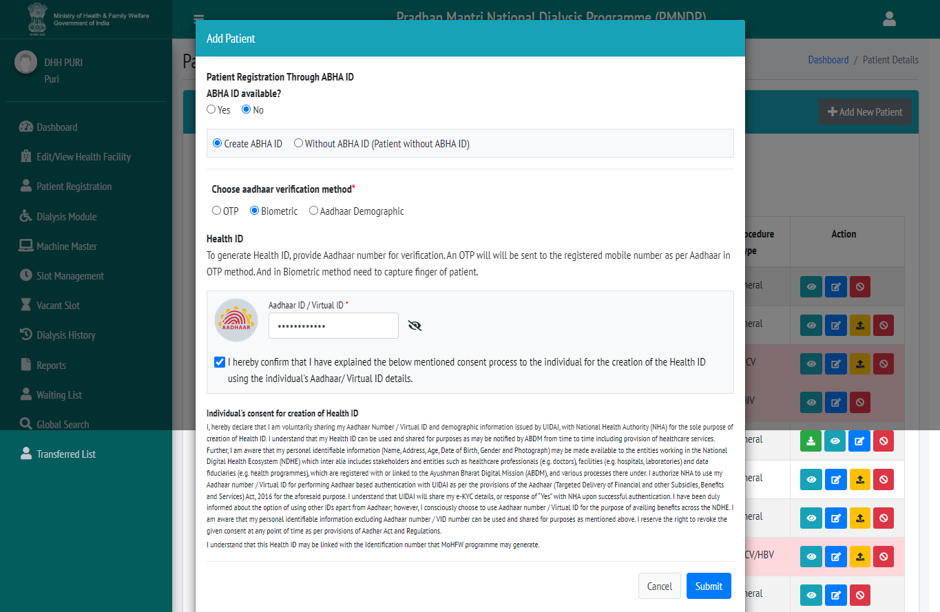

- ABHA ID available select NO.
- Select Create ABHA ID.
- Choose verification method select OTP.
- Enter valid Aadhar number.
- Check the confirmation checkbox.
- Click on submit button.
You will redirect to biometric page

- Click on click here
- Verify your finger and verification successfully then click on continue after verification successful redirect to patient profile page.
- You will redirect to profile page same records will display auto file and some fields you have to fill and click on save.

Aadhar Demographic

- Facility can register Patient without verification.
- Facility will add with Aadhar number, Aadhar based Name, DOB, Gender, and Mobile Number.
- Name, DOB, Gender should match with Aadhar number.
- Aadhar based Mobile Number enter so SMS will receive in Aadhar based Mobile Number.
- Facility can enter any mobile number no need to enter Aadhar based mobile number
Click on add new patient add patient popup will open.

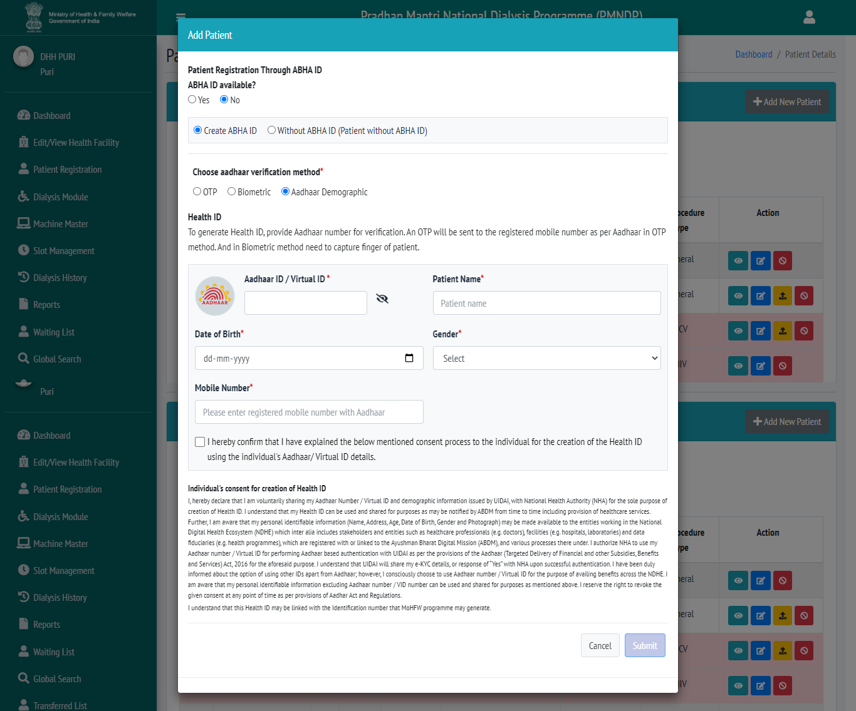
- Aadhar ID available Select NO.
- Choose Aadhar verification method Select Aadhar demographic.
- Enter valid Aadhar number and other information
- Select checkbox
- Click on submit
- Patient will register successfully not you can see in patient list and you can schedule the patient dialysis.

Without ABHA ID
Facility can add patient without ABHA ID and without Aadhar number

Patient register by DOB and Mobile number
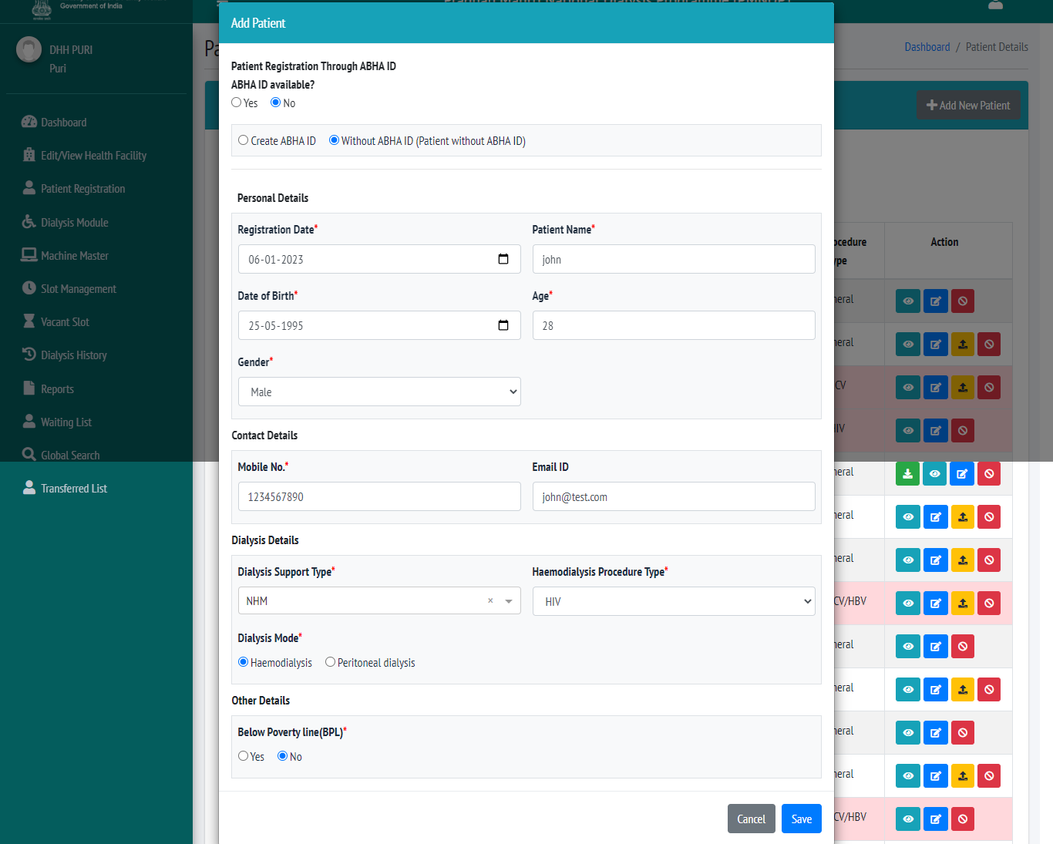

Fill all fields correct records and click on save patient will register successfully.

Link with ABHA ID
If Facility register patient without ABHA id and without Aadhar number so facility can link the patient with ABHA id.
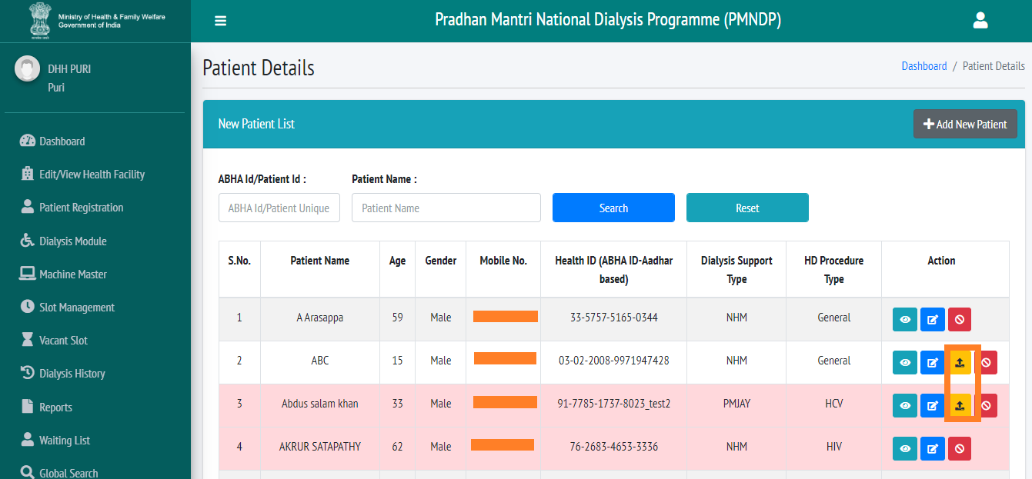

Click on the mark icon this page redirect to register page and you can link with ABHA id direct and you can create ABHA id by Aadhar number.

Patient List
Patient list page Facility can search the patient by ABHA id and patient name.

Download Health Card
After register by Aadhar card and health id so facility can download the patient health card.
Facility can click on download icon which is mark is given screen short.

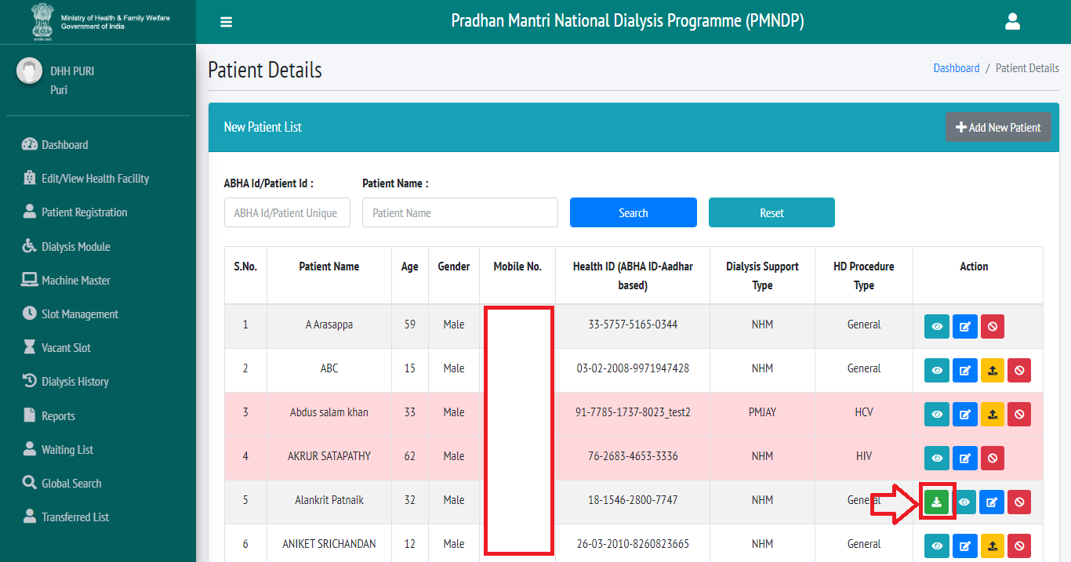

Edit Patient Details
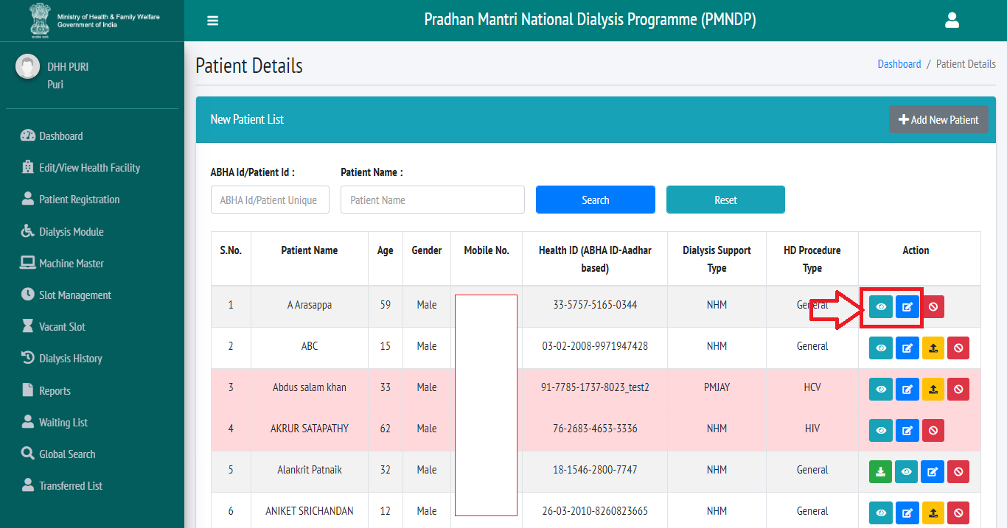

Facility can edit the facility details.
Click on edit icon one new popup will open and facility can edit facility details.

View Patient Details
Facility can view the patient details click on view icon.

Deactivate/Activate Patient
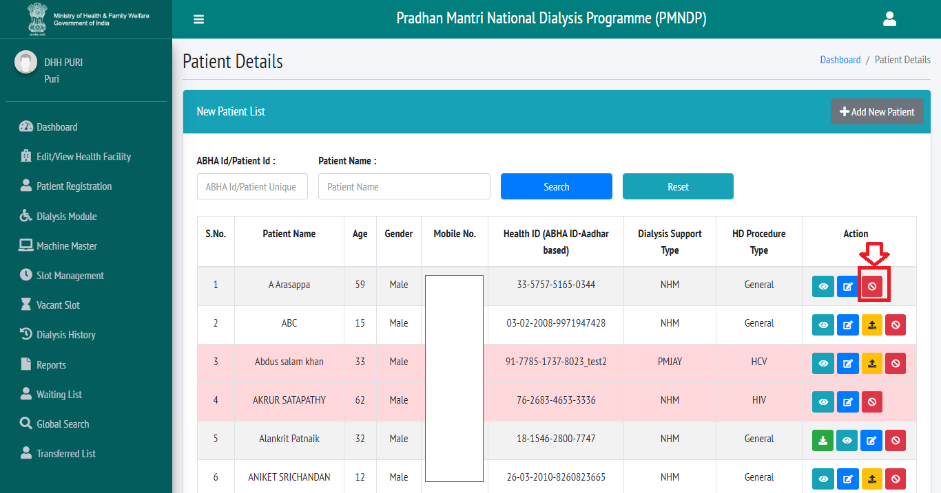

Facility can deactivate and activate the patient click on the mark icon in screen short.

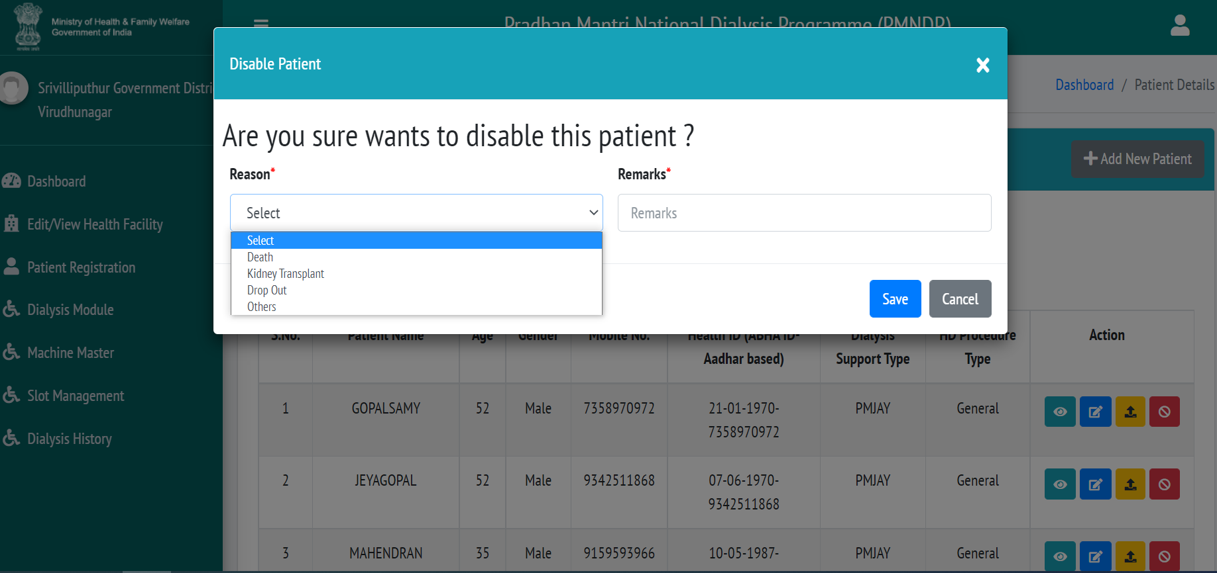

- Facility can deactivate or activate any patient as per the situation or circumstances.
- Click on red button
- Select the reason
- Give remarks.
- Click on Save.

Add Machine Master
Click on add new machine and add the machine details click on save.
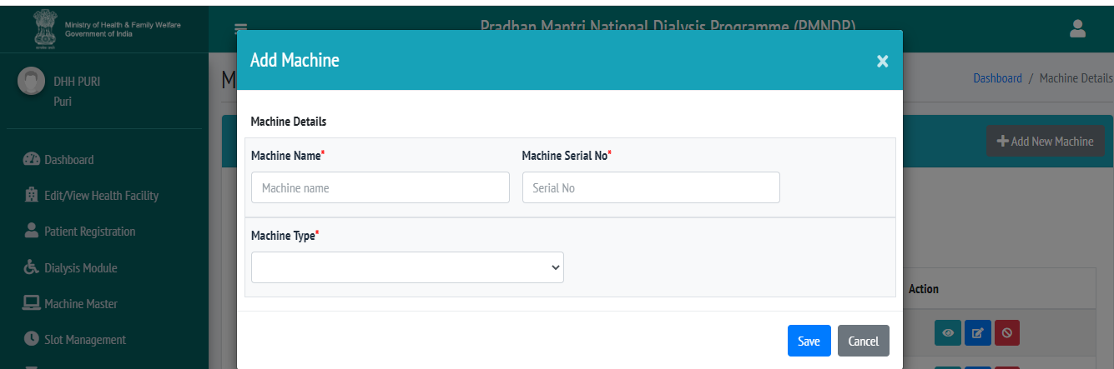

Facility can add the machine by click on add new machine
Facility can view edit and delete the machine
Facility can search the added machine.

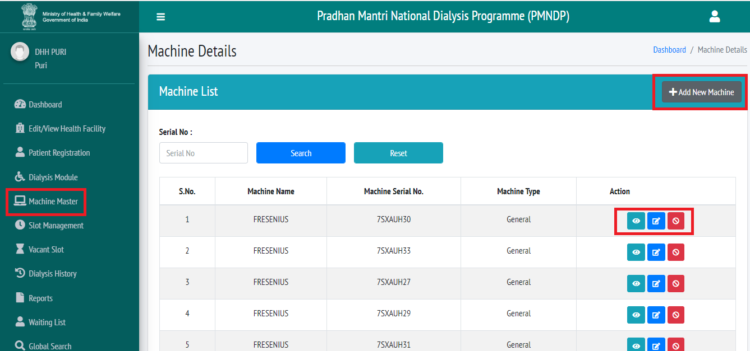

Slot Management
Click on add new slot facility can add slot for available machine.

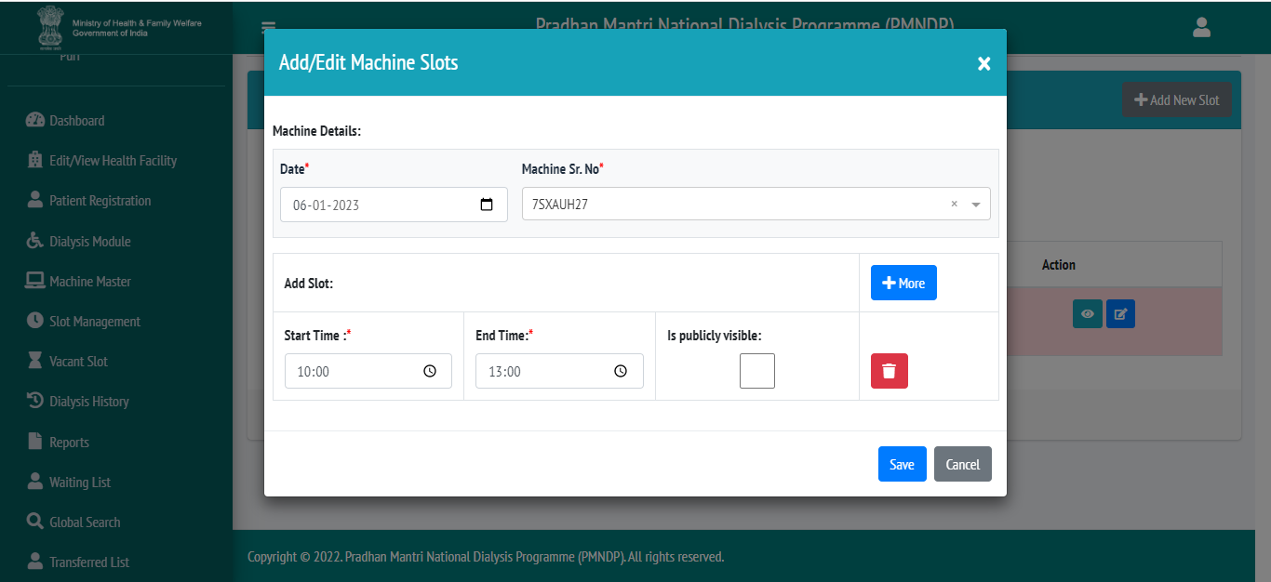

Select date.
Select machine Sr. No.
Slot start time and end time.
Click on save
Facility have more option so they can add more slot for same machine.
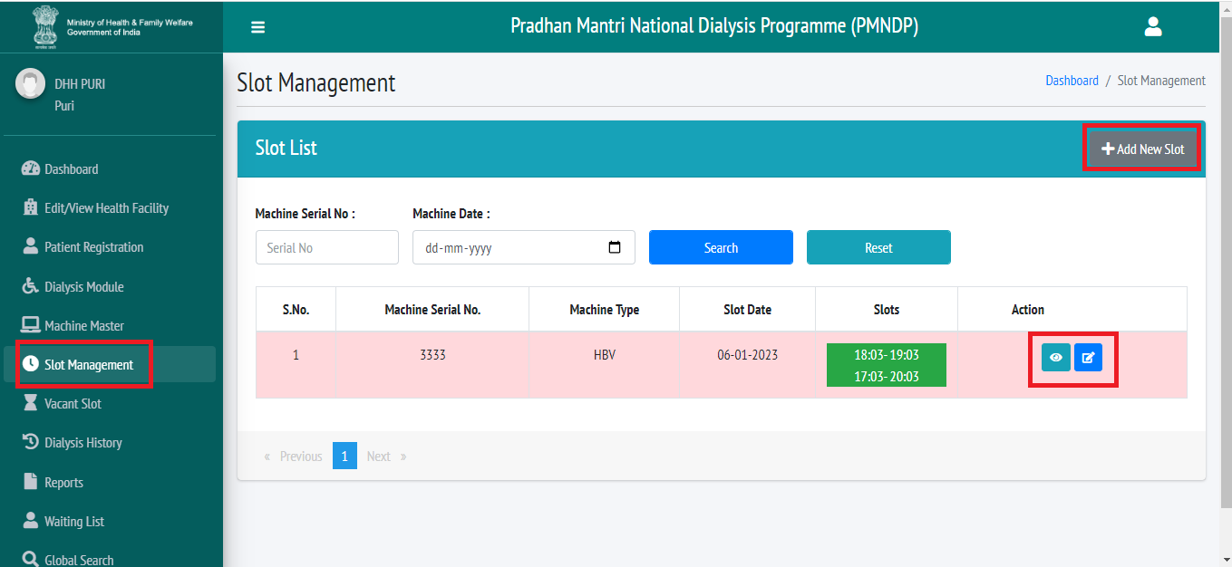

Facility can search the slot by machine serial no.
Facility can view and edit machine.

Dialysis Module
In Dialysis Module, All the registered Patient listing show in the Dialysis module with Fresh Status.
Facility can search the Patient by using Name, Mobile number and Dialysis type.

Facility can schedule the Dialysis of Patient, Start the dialysis and complete the Dialysis. Facility can also unbook the dialysis of patient if he doesn’t come for dialysis, so that the vacant slot will be available for needy person.
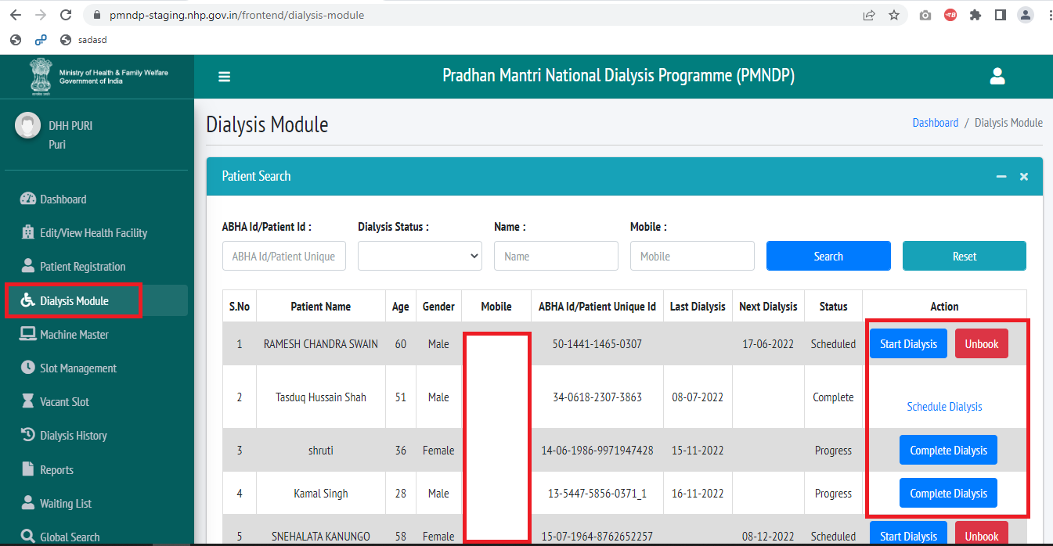

Dialysis History
In dialysis history facility can see the patient dialysis history.
Facility can search the patient by patient name ABHA id dialysis status.
Facility can export in excel the patient dialysis history.
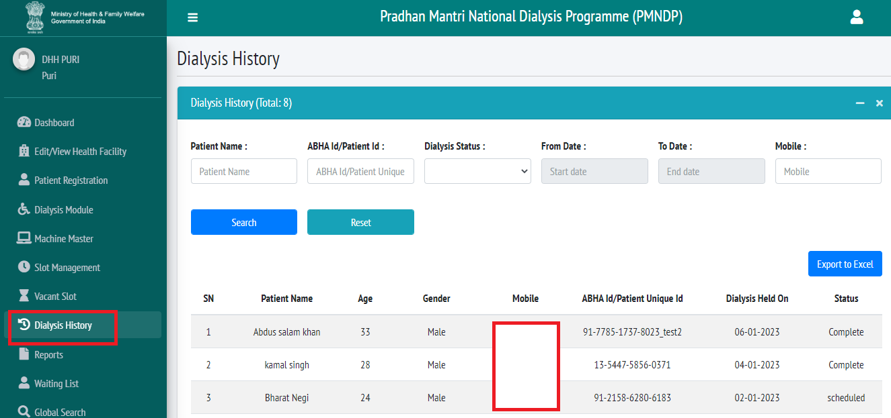

Waiting List
If Facility does not have available slot for patient who come for dialysis, facility can register that patient in to waiting list.
After available slot facility can shift patient waiting list to patient registration page and it will display in dialysis module so facility can schedule patient for dialysis.

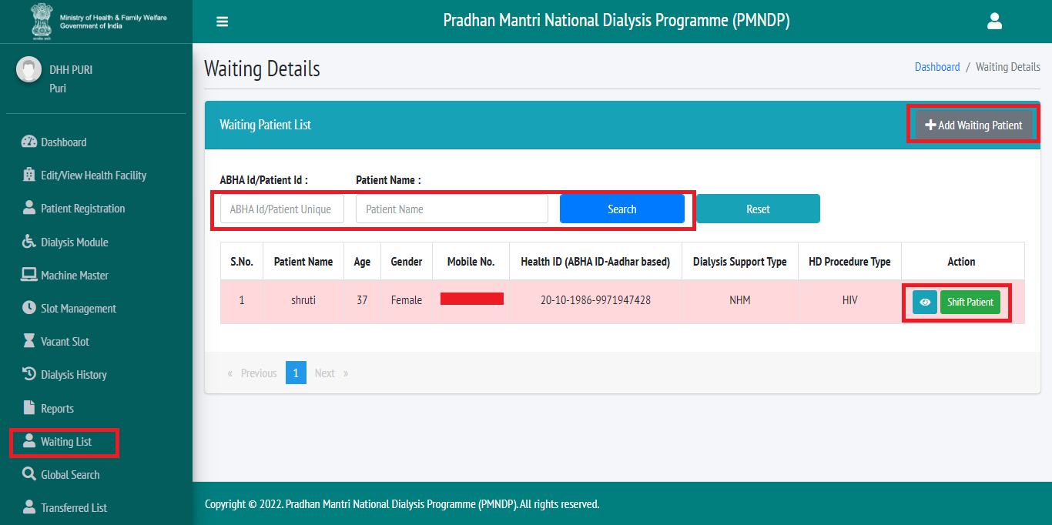

Add waiting Patient

- Click on patient list
- Click on add new patient
- Facility can register patient same option available like add patient.
- Facility can register patient with ABHA id two option available for verification OTP and biometric.
- Facility can register patient with Aadhar number three option available OTP, biometric and Aadhar demographic.
- Facility can add patient without ABHA id and Aadhar number patient can add by mobile number and date of birth.
- Facility can search patient by ABHA id and patient name.
- Facility can view the patient detail click on view icon
- Facility can shift patient.
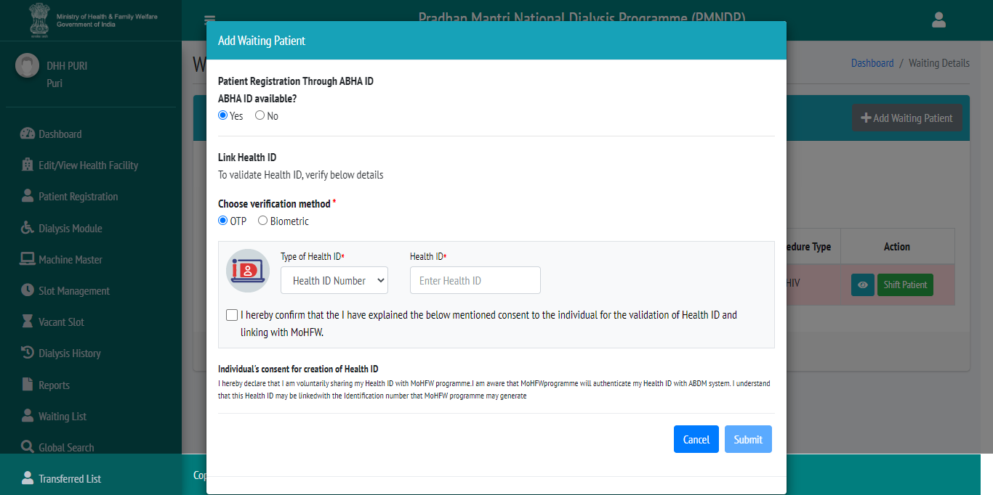

Shift patient
- Facility can shift the patient from waiting list to patient registration page.
- Click on shift patient one popup will appear you want to shit or not.

Reports
Click on Reports tab Facility can Select Report Type, from date, to Date.
Select reports type Facility can see multiple type reports, Report will Export according to date selection.
- Patient with ABHA ID
- Patient without ABHA ID
- Dialysis Machine List
- Patient Hemodialysis Count
- Monthly Progress Report
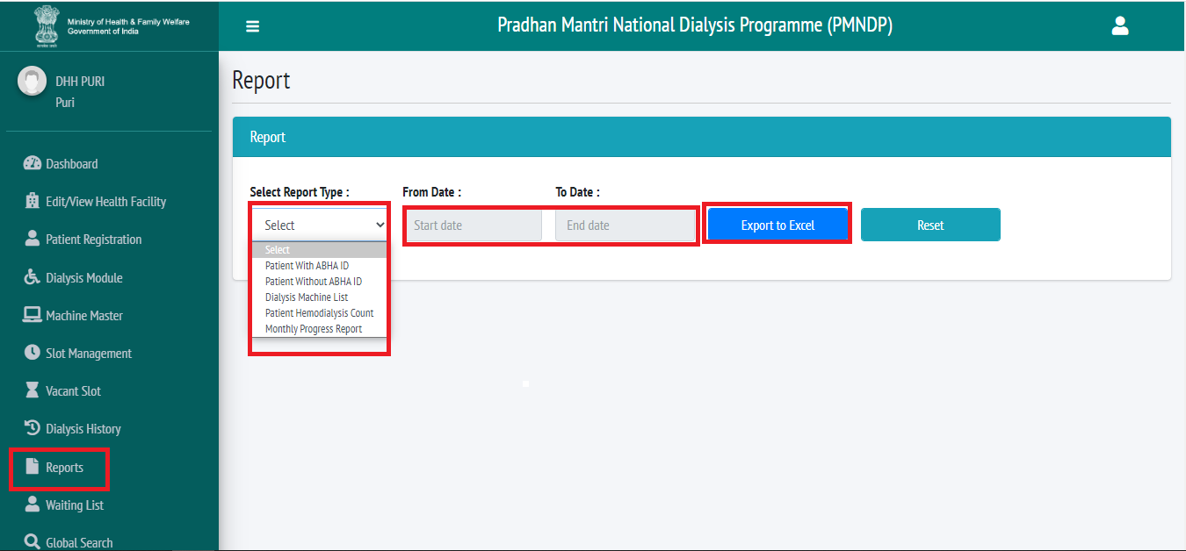

Global Search
- Facility have access to search patient globally if any patient want to move his registration any other location so facility can transfer to patient his location and patient can dialysis another location
- Facility can transfer to patient which register to other location or other district they have facility that facility can transfer to patient his location and district.
- Facility can search to patient with ABHA id/Patient id, Patient Name and patient mobile number.
- Facility can view the patient profile.
- Facility can see Patient dialysis history.
- Facility have one reset option which will remove the search data and refresh the page.
- Facility can transfer the patient it will ask for the transfer reason which will be mandatory field.
- Click on global search.
- Facility can search patient by ABHA id, Patient name, and patient mobile number.
- Facility can view patient details.
- Facility can view patent dialysis history.
- Facility can transfer patient other facility to his/her account.

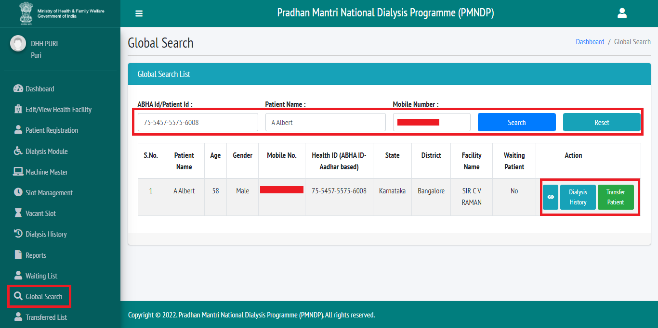

Click on transfer patient so one popup will display so facility have to give the region.

Transfer List

- Click on transfer list from left menu all transferred patient list will display.
- Those patients will appear in the transfer list who have been transferred from the list of facility to other facility.
- Facility can see the transfer patient profile.

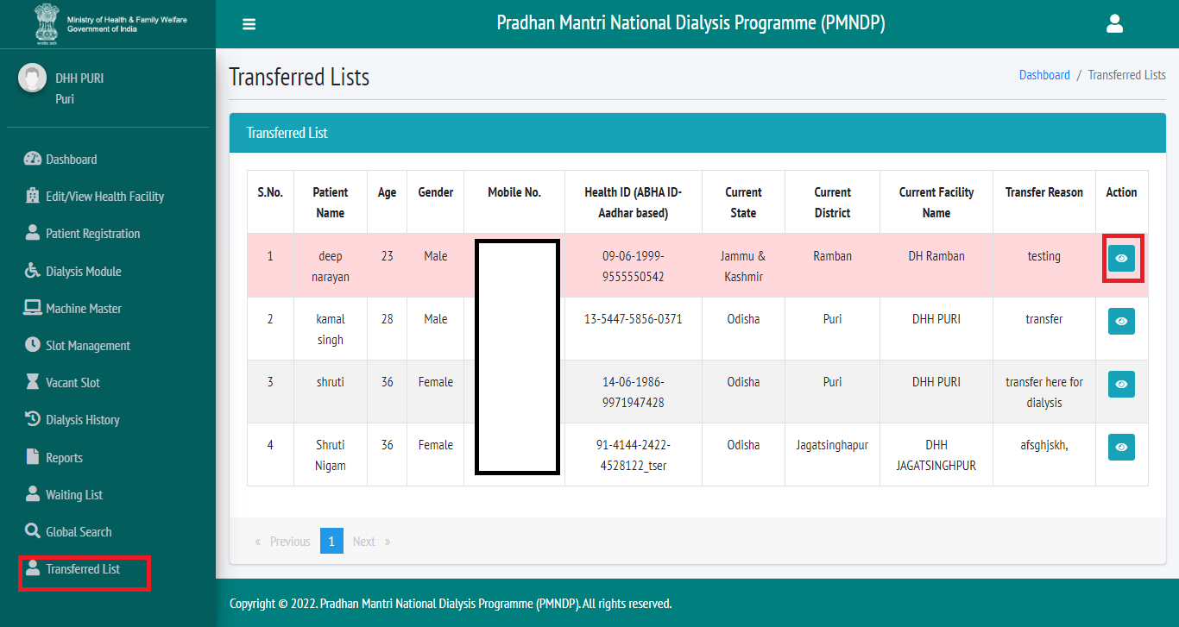

HFR Module
HFR (HEALTH FACILITY REGISTRY) SELF REGISTRATION FORM:
At login there will be a box of REGISTER HFR.
- Click on REGISTER HFR new popup will open.
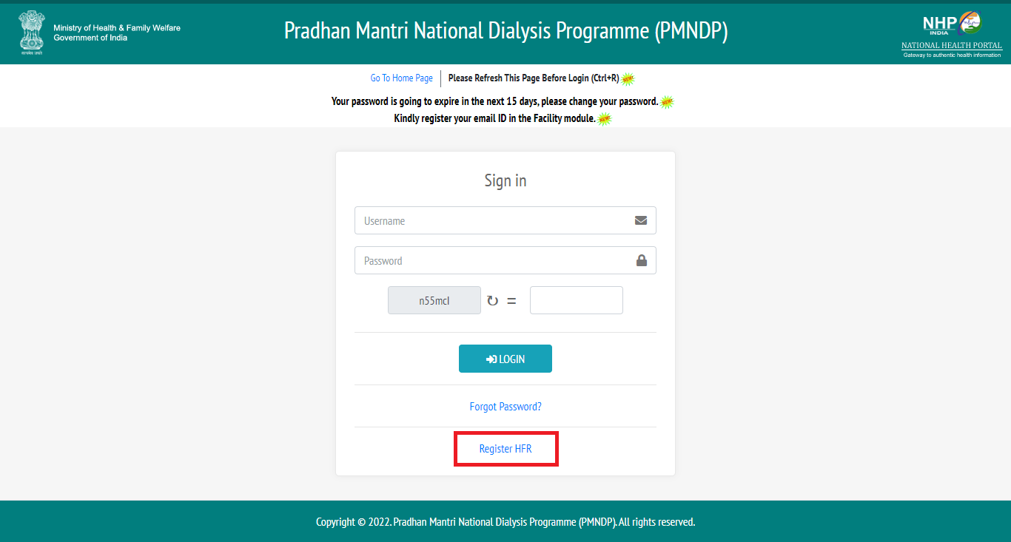
Click on HFR new popup will display.
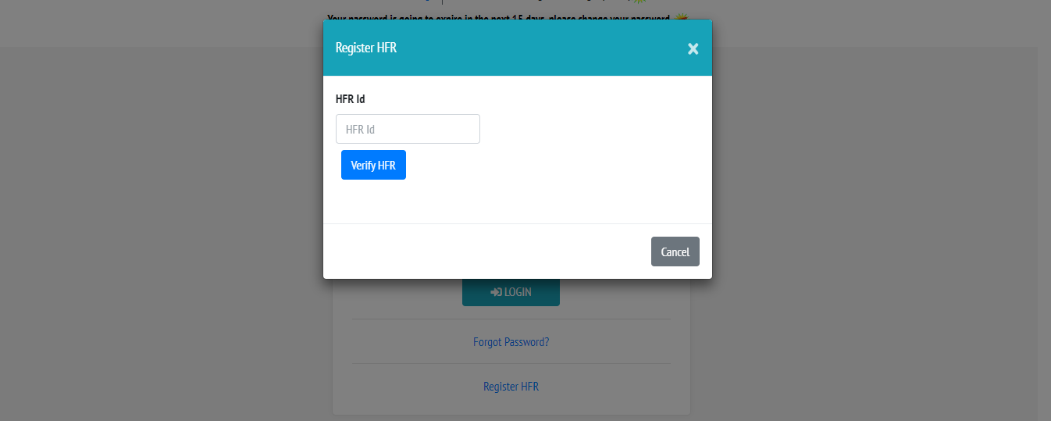
- After Click on Register HFR one popup will open where facility can enter HFR id.
- Verify HFR
- If HFR exists: OTP will be sent to registered mobile no. through ABDM API
- If HFR does not exists: This HFR does not exist message will be reflect.
Enter HFR
- Verify OTP complete form will open
- After validate OTP
- The details will be reflected in the form
- Facility can fill other details and click on register
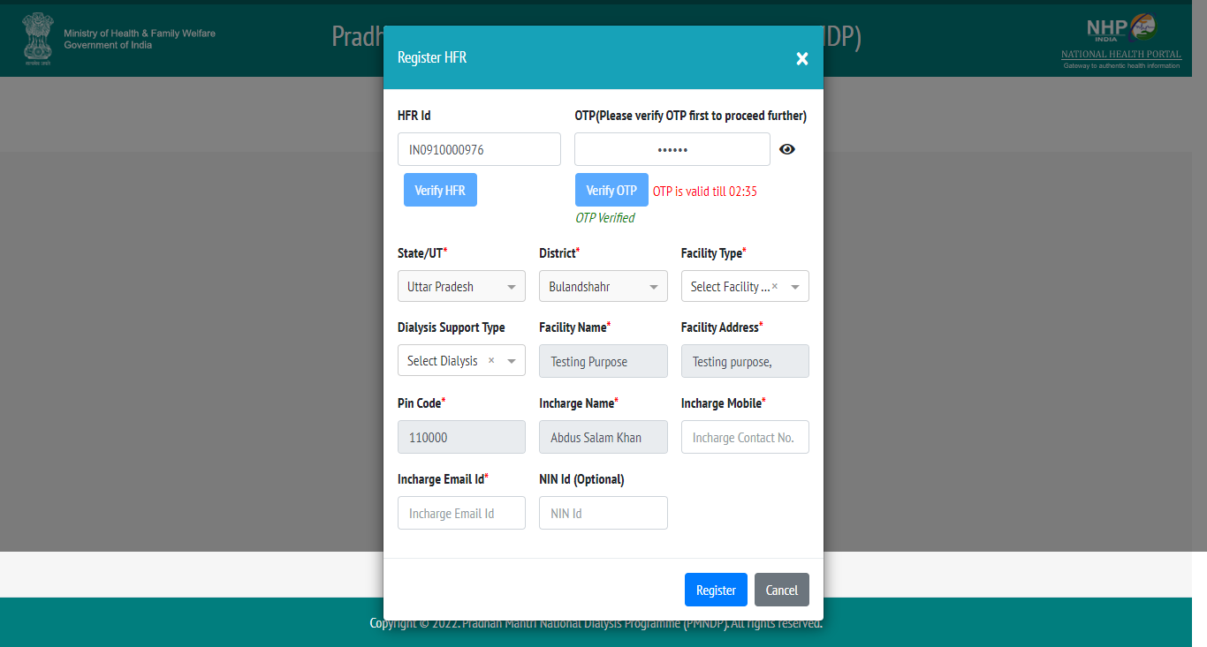

Thank you

